Azure Traffic manager

1. It is a regional load balancer and application gateway within the region only it can do
2. Whereas traffic manager does regions to regions
3. If our VM is in East US and replication is in west US then traffic manager will manage the alternative region and traffic without any issues
4. Traffic manager will send the traffic but not like load balancer ( sending traffic to back end instances using the front end IP)
5. This is like a DNS service

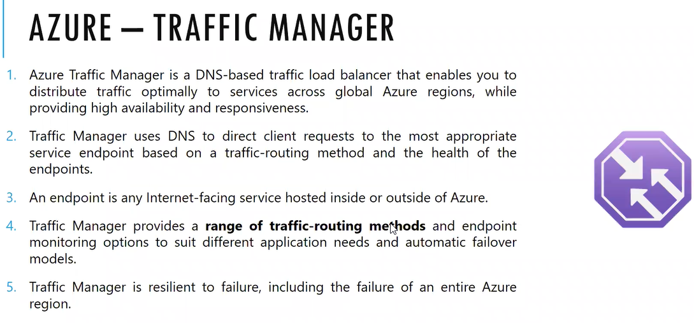

Routing methods:

Priority : NOT the backend pools it is a end point we will configure primary and secondary end point. More traffic will send to primary end point and if fails it will forward to secondary end point

Weighted: we can define percentage how much traffic will go for primary and how much it will go for secondary

Performance: if our deployment is present in different geographical regions the traffic will send to nearest location based on the network latency

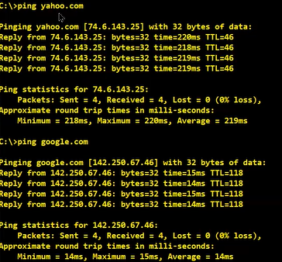

For google it will take 15ms for round trip

Geographic: send the packet to the nearest geographical location , nearest routing

.com.in – India ; .com.jp-Japan

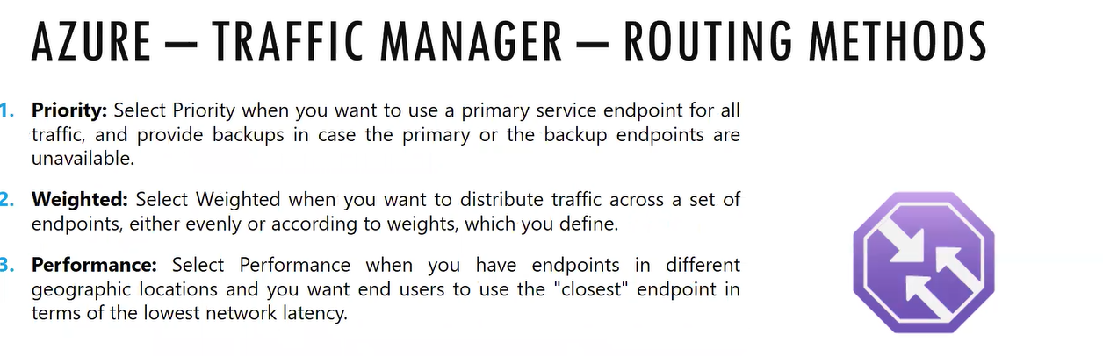

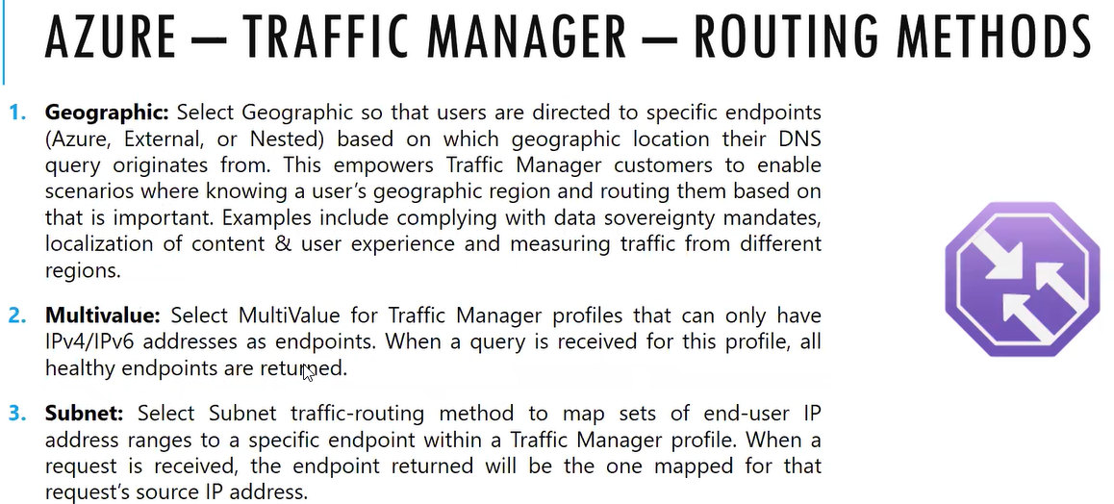

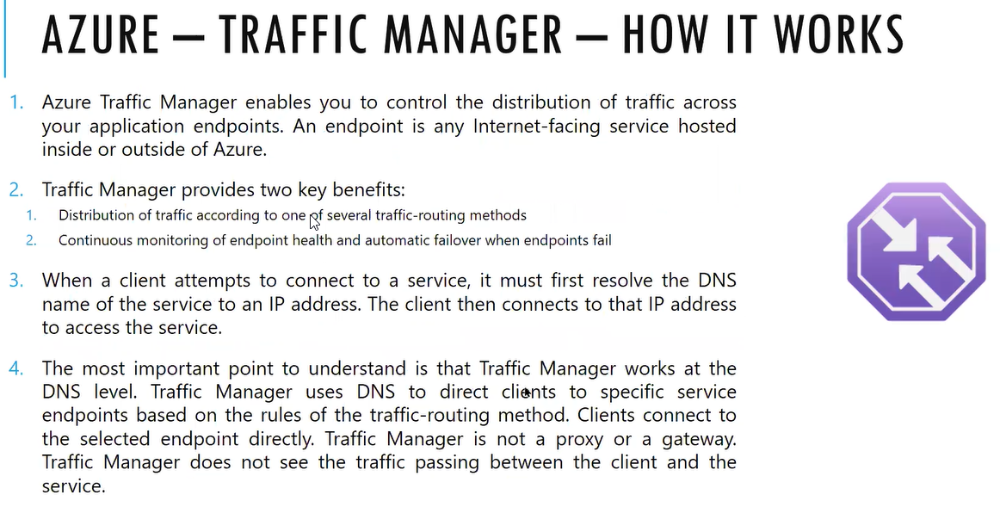

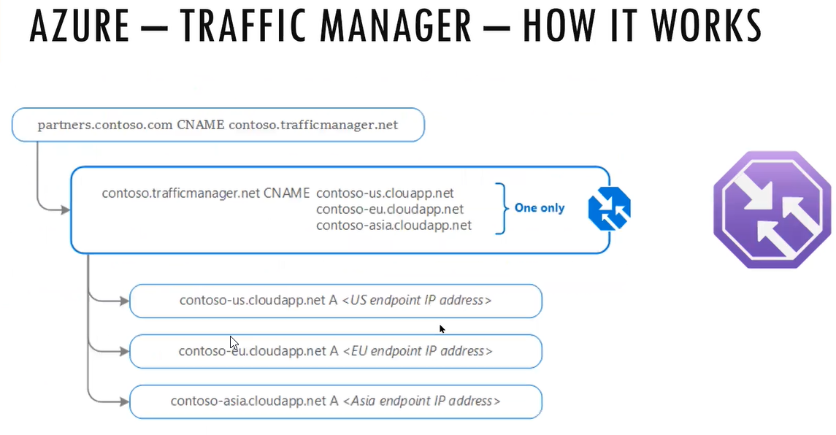

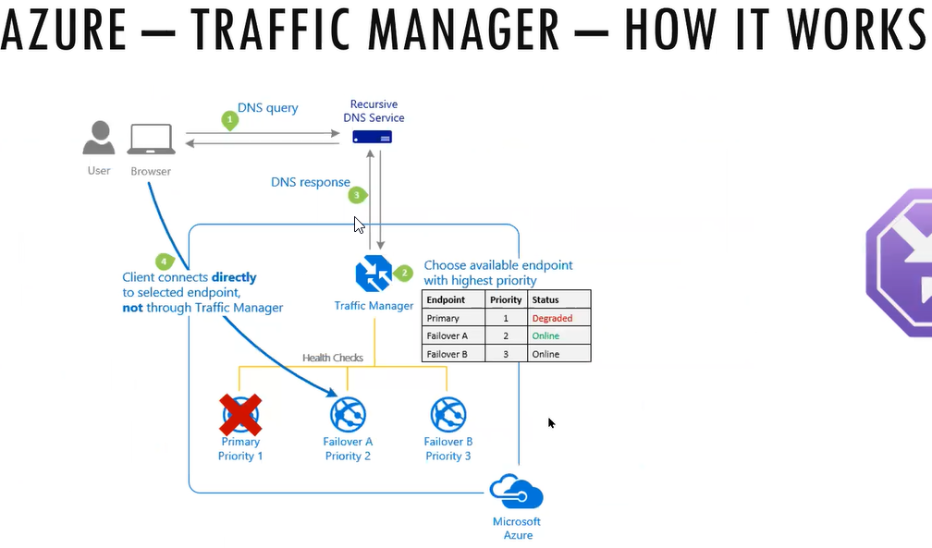

There will be different range of routing methods for Traffic manager

In AWS it is Route 53

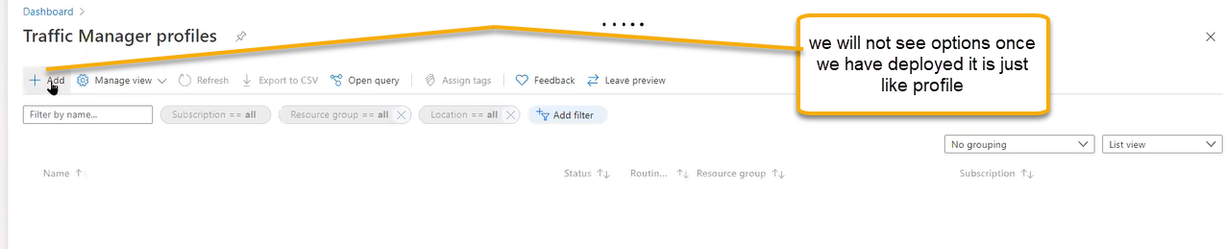

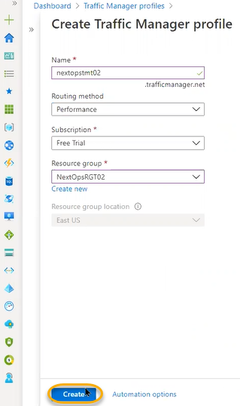

If end point is working, then it is healthy and if not working then DNS will come to know it is degraded. DNS will divert the traffic to the healthy endpoints

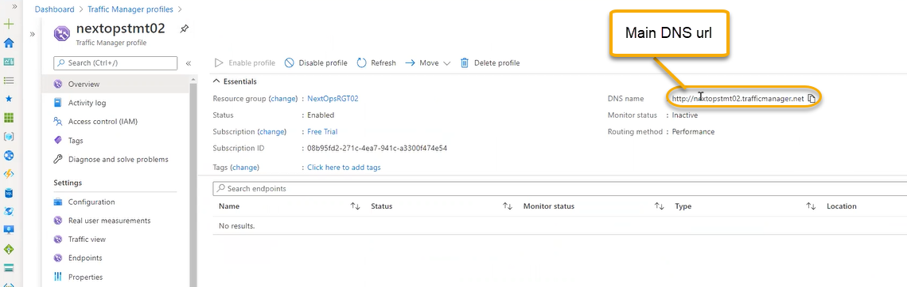

Above url is public IP and if you ping that

Nested endpoint: traffic will be send between one traffic manager to another traffic manager 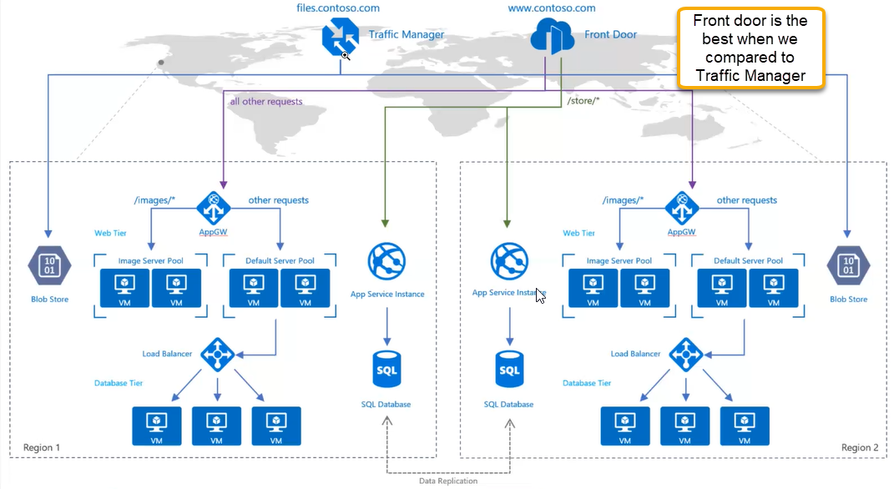

End point related to every record traffic manager will note and maintain in their table

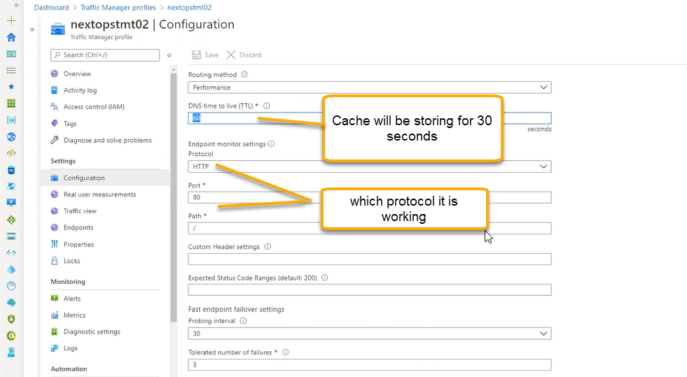

Real user measurements: in the web app we have options real time

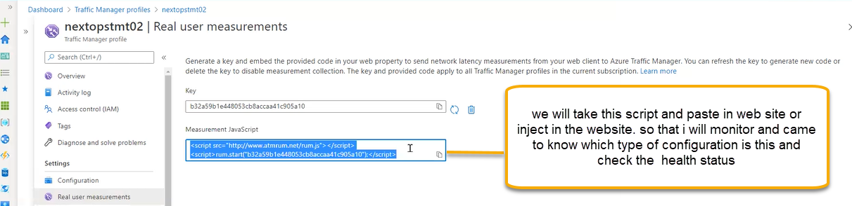

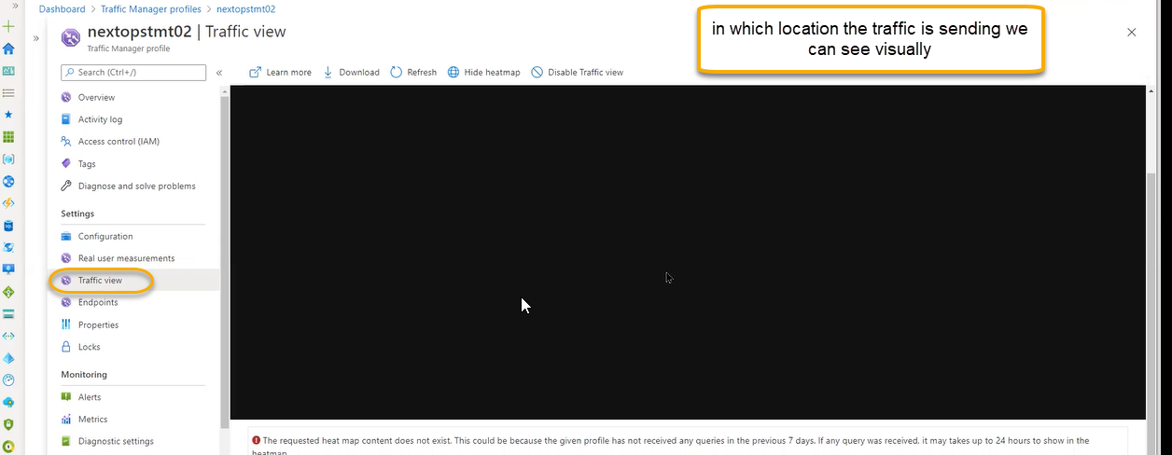

It is just like analytics how much heat map it will take how many browsers they are using at what traffic is more in how many regions we are getting the traffic

We can clone one App service so that it will replicate in another region it will create the mirror images in one region, one App service is added to one end point and another app service is added to one point so that two regions will be added in the backend point based on configuration it will transfer to traffic

App services

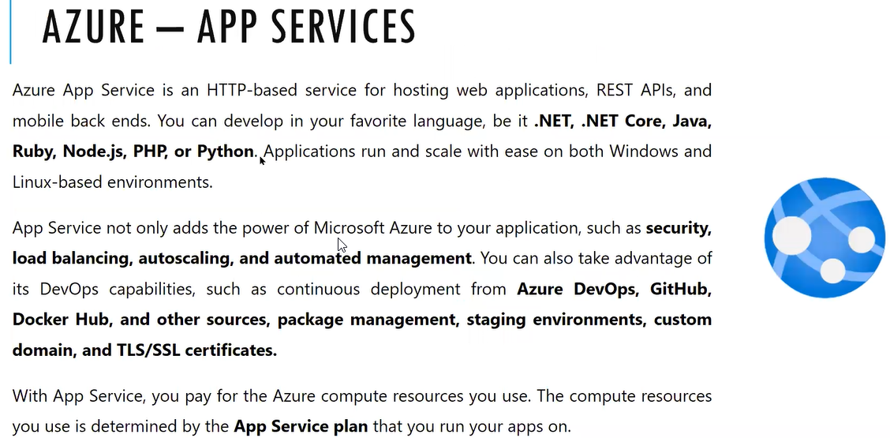

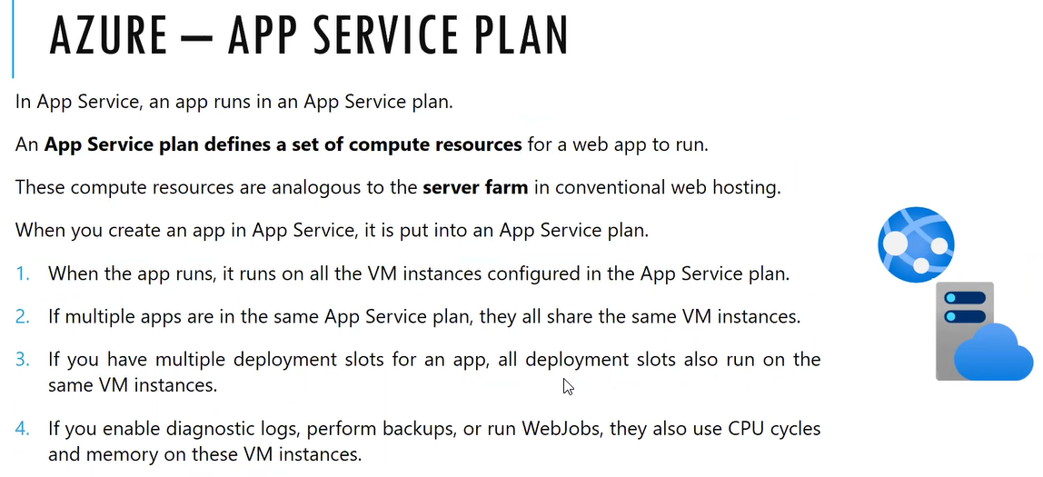

It is pure PAAS Service. PAAS Security center, Azure active directory, load balancers, gateways, firewall, bastion,

Priority App services is Web APP

In the IAAS we will install the virtual machine in the above we will install web server in that we will host web site

We have more control on this

PAAS: First launched project in Azure is PAAS We cannot login to the machine

Website/mobile services will support app services

App services will publish the website through public end point we can place behind the load balancer or traffic manager or front door

Deployment we can do manual or we can push through azure devops

First we need to create the app service plan

It will define the resources like cpu , ramhow many web apps need to run

In app services plan we have multiple VMS in the background

Depends on the plan the cpu ram will be varied

If two web sites are using the same service plan then they will share accordingly

App services

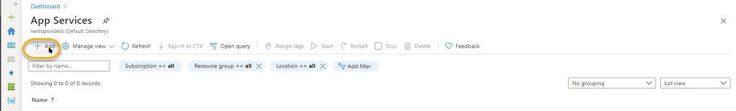

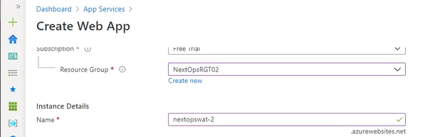

Operating system if your using Tomcat, Apache server we can select linux and if your using internet services then we can use Windows

For creating the wep app plan we need app services plan

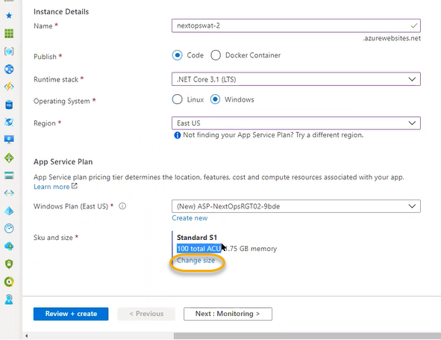

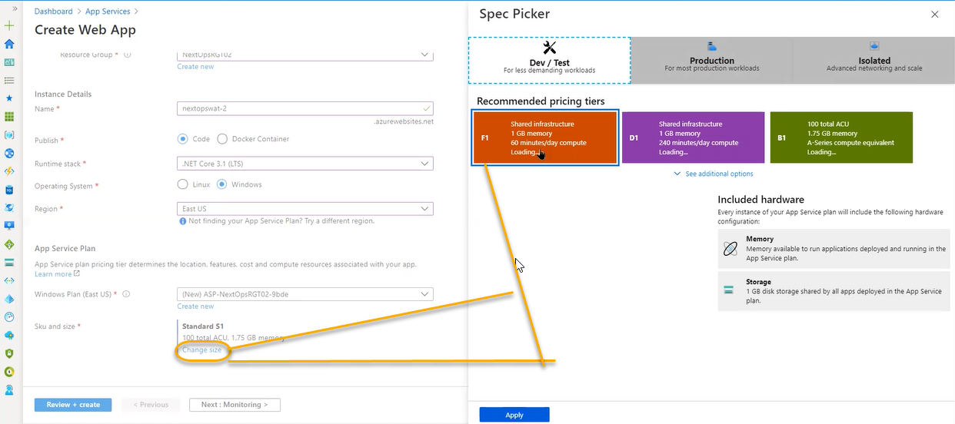

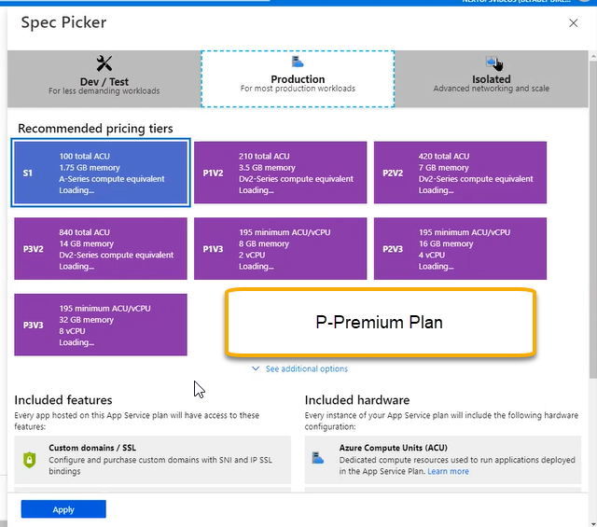

Isolated: For our Virtual machines it will be isolated

We deploy inside the Vnet

ACU: Azure computing unit which is also A series and it is general which is equivalent to one virtual CPU

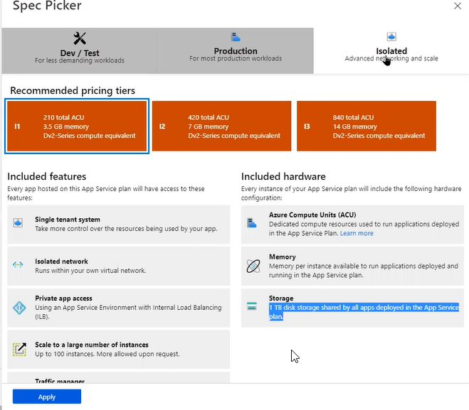

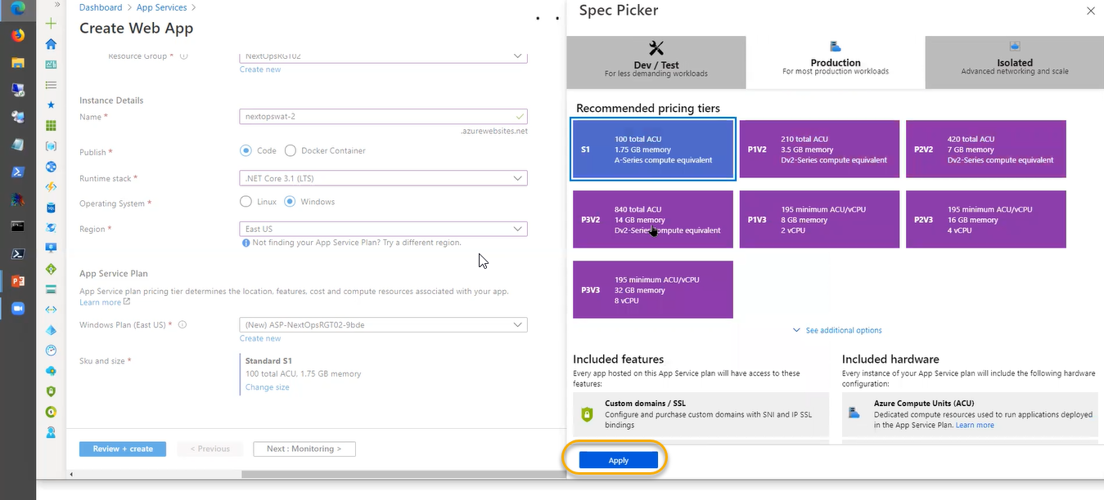

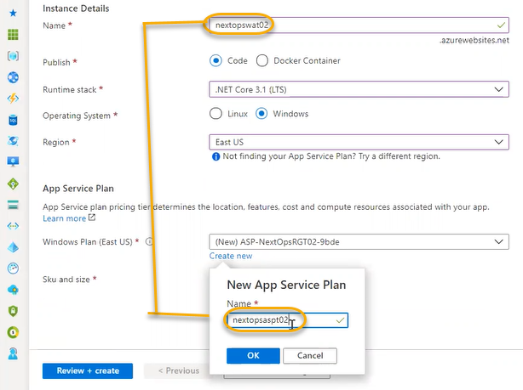

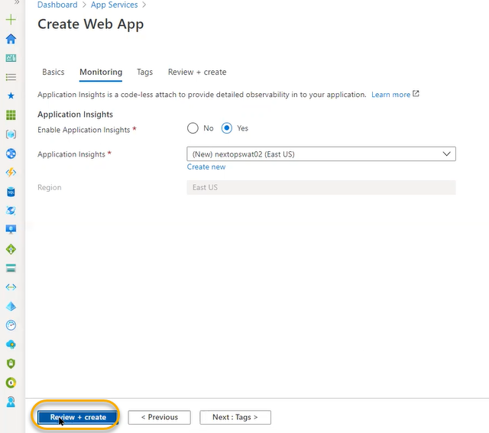

Click on Create

Once the app service is deployed we can see public url is generated which can accessible from nay where

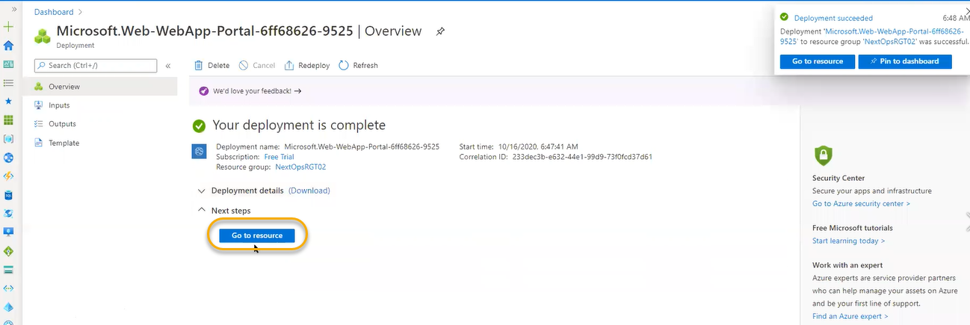

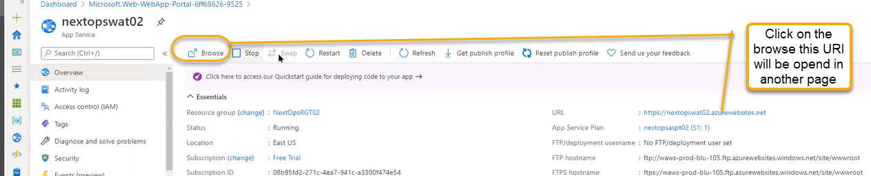

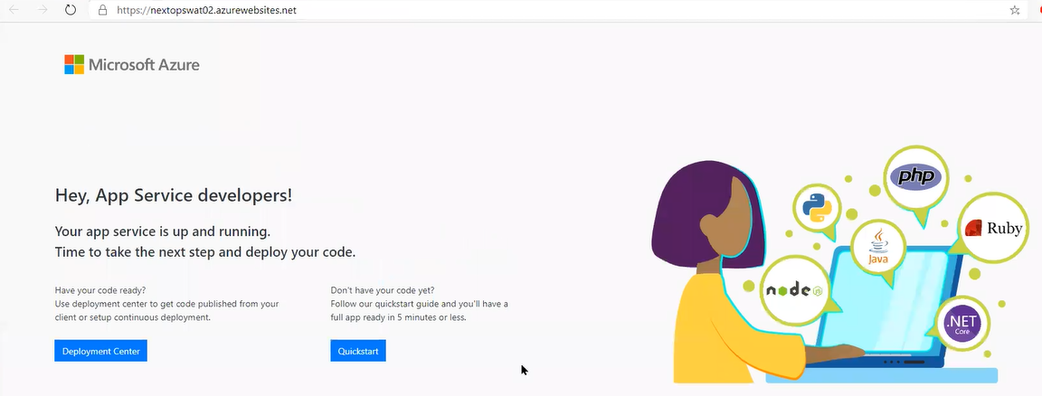

If you click on the stop then backend instances/services will be stooped

Restart : if you want to clear the cache then we can click on the Restart

Publish profile: we can download the profile and we can reset ftp related

In generic deployments in on premises using the ftp service they will upload the code however this is old process we can do it in the devops

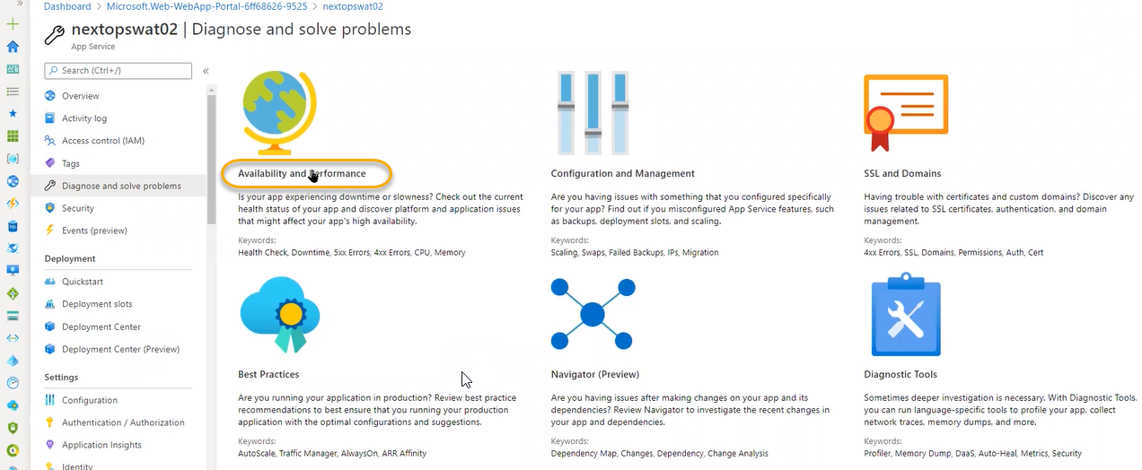

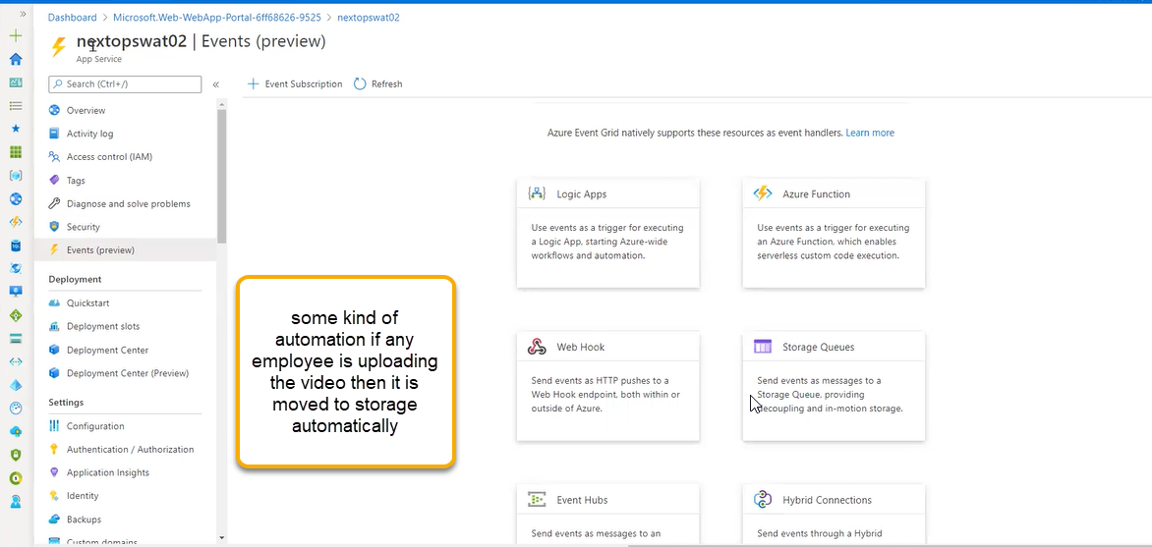

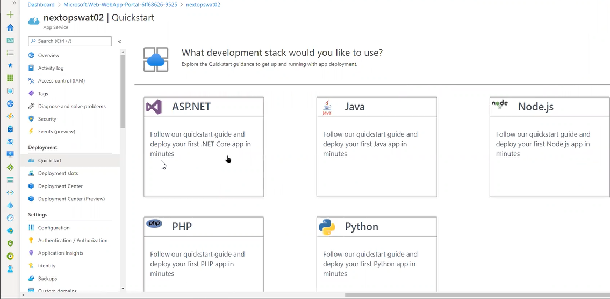

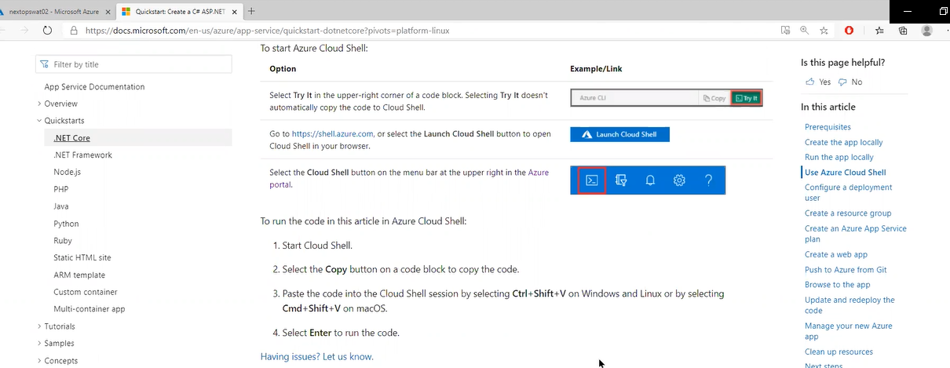

Deployments slot: usually in the on premises environment deployments will be maintained by one dev environment and UAT and production ( it is available in the public website)

The three environments are isolated and mirror images to each other dev = UAT = Production

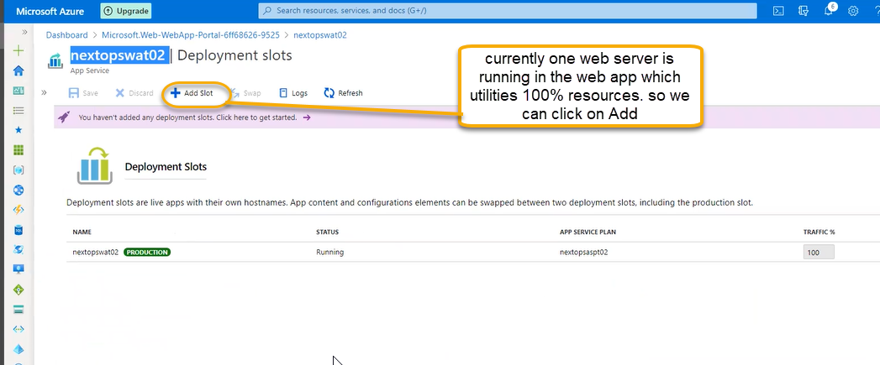

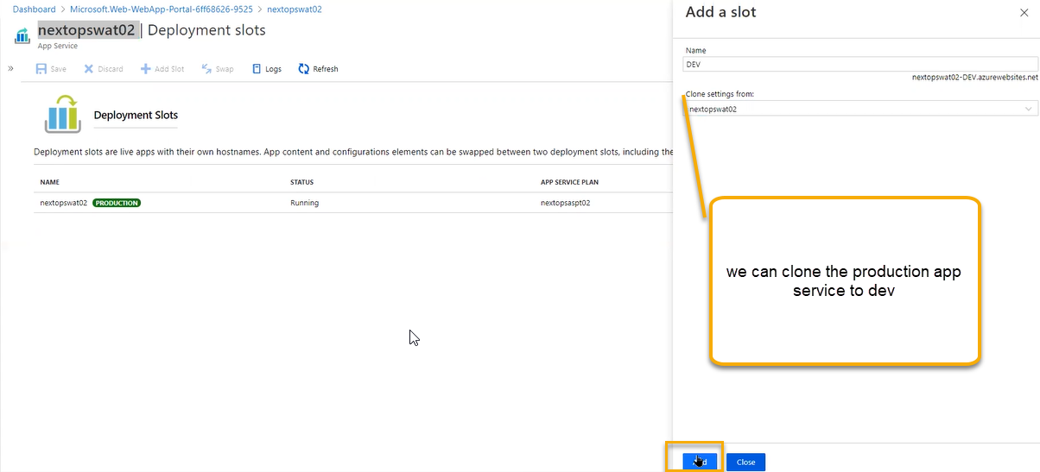

Once the slot is created we can define the percentage of traffic how much it has to go production and dev

Cloning is nothing but production mirror image dev

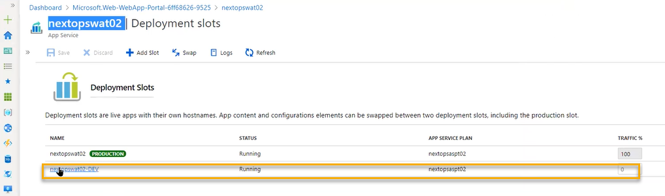

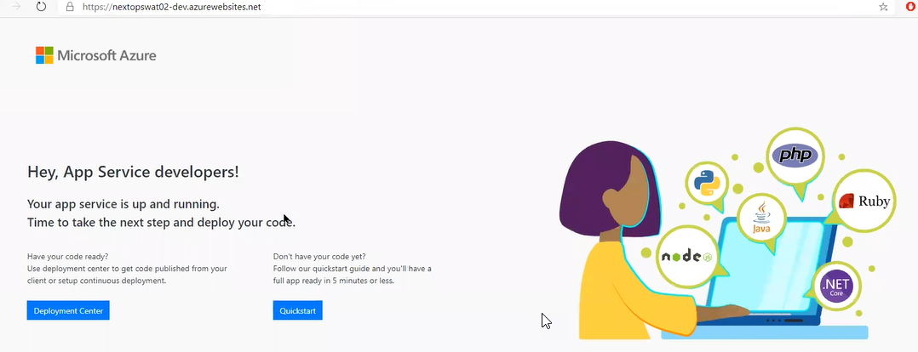

Updated code we can push in the dev slot

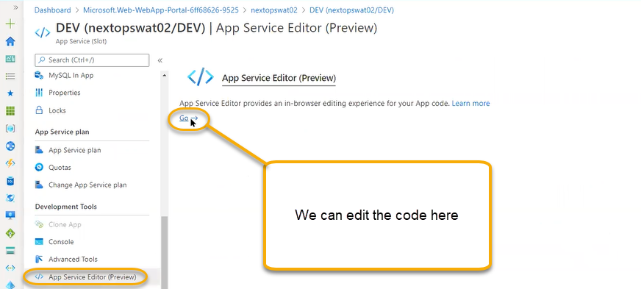

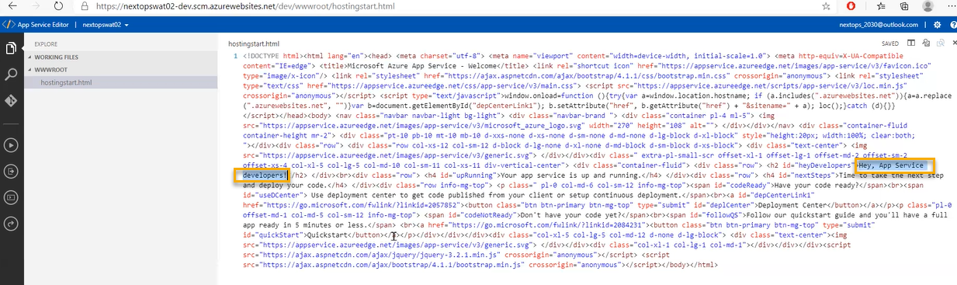

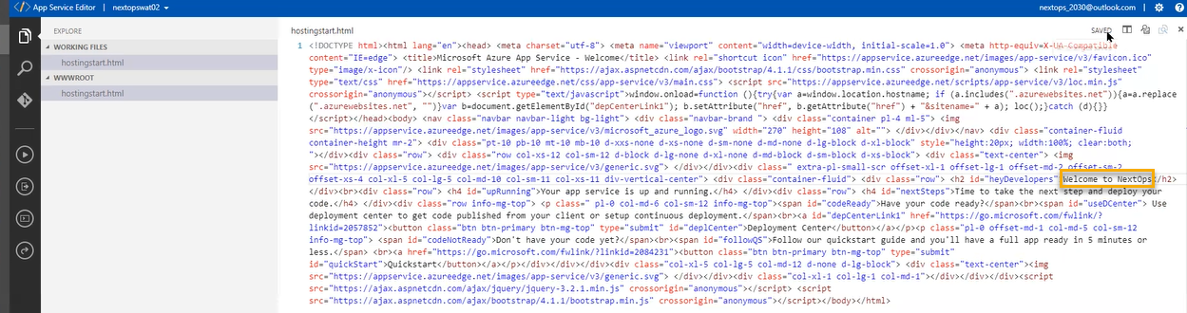

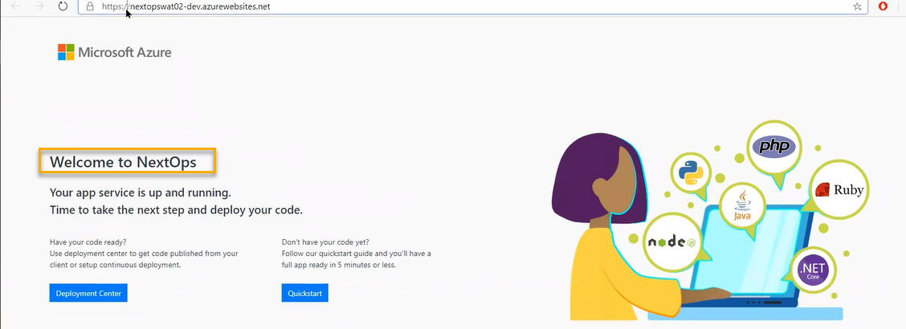

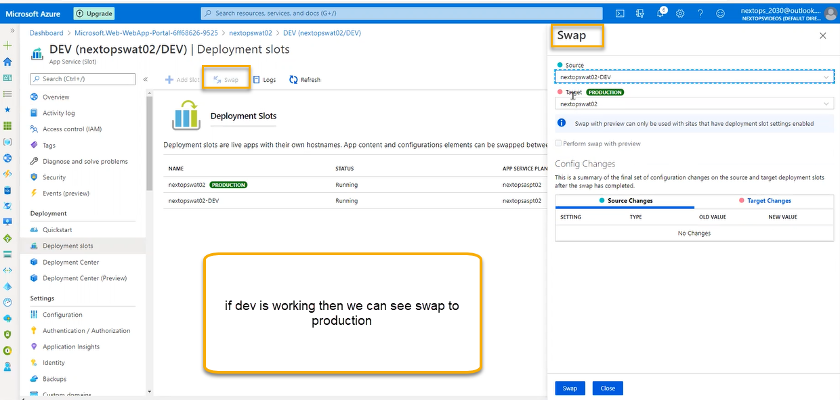

After swapping if we see issues that it is degraded, and we have bugs

And again, we can swap it